**AP Government and Politics:**

**The Redesigned FRQs**

**OCSS—SW Workshop**

David Wolfford

Mariemont High School

[www.usgopo.com](http://www.usgopo.com)

[www.davidwolfford.com](http://www.davidwolfford.com)

[dwolfford@cinci.rr.com](mailto:dwolfford@cinci.rr.com)

FRQ Style #1

(Released Exam 1)

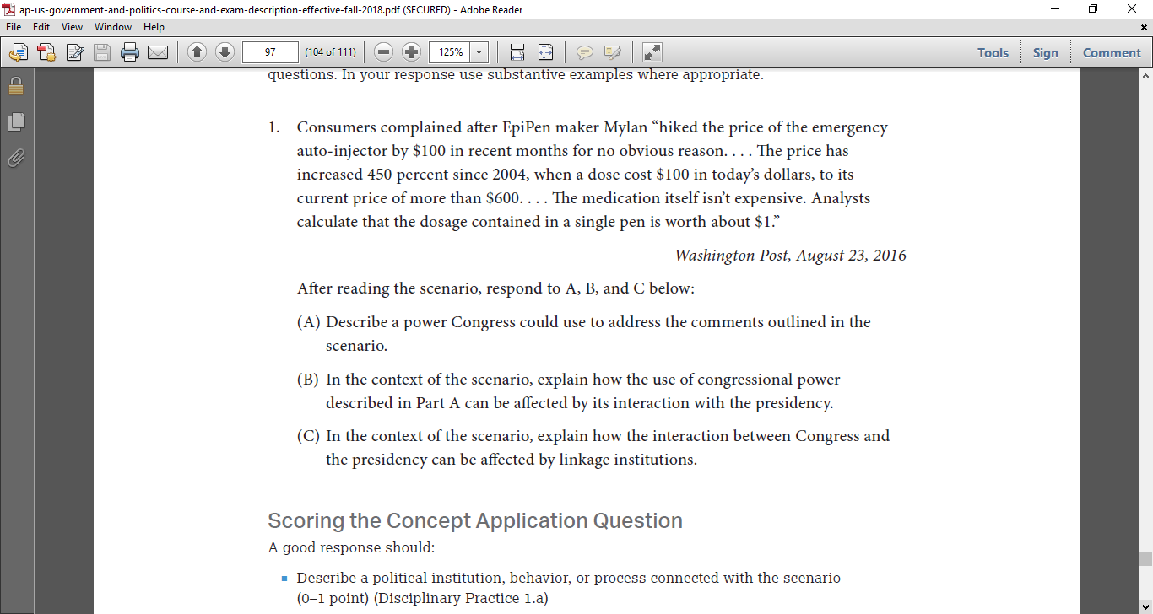

FRQ Style #1

(Released Exam 2)

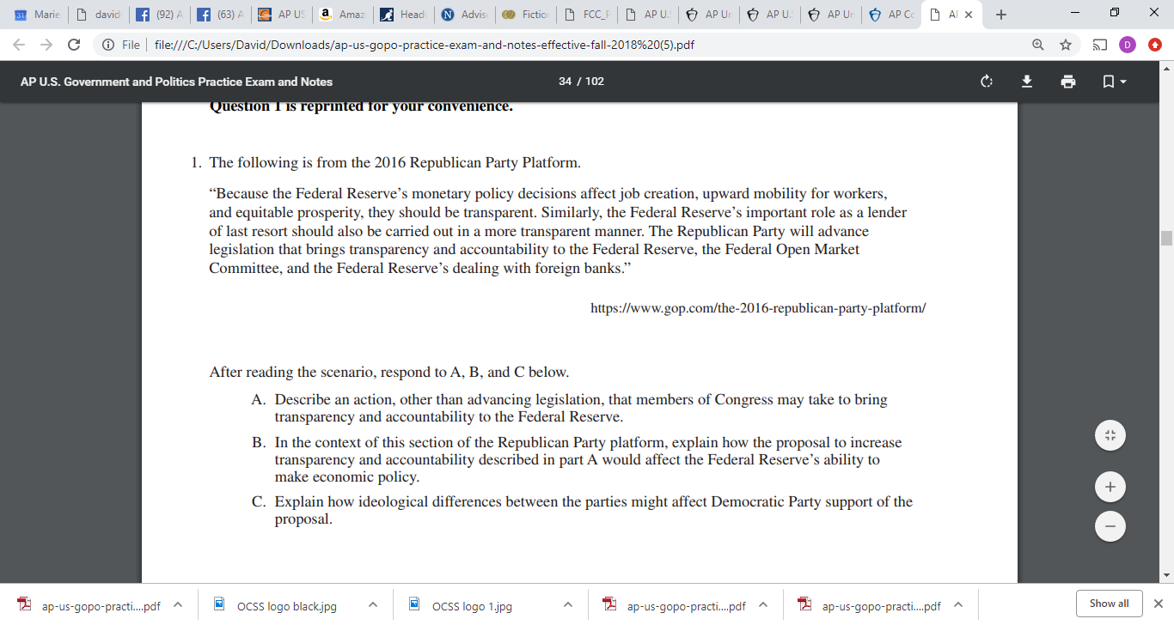

Suggestions from College Board

Students will have to:

* Describe a political institution, behavior, or process in connection with a scenario.
* In the context of the scenario, explain how the response in part A affects a political process, government entity, or citizen behavior.
* Explain how the scenario relates to a political institution, behavior, or process.

FRQ Style #2

(Released Exam 1)

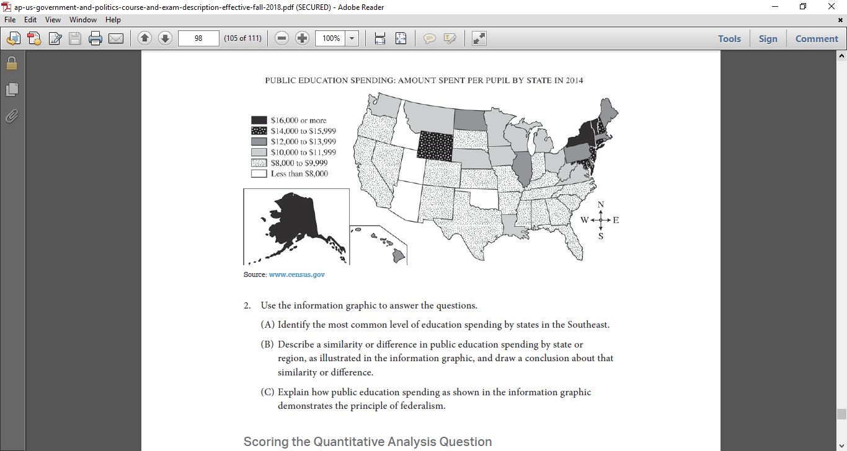

FRQ Style #2

(released Exam 2)

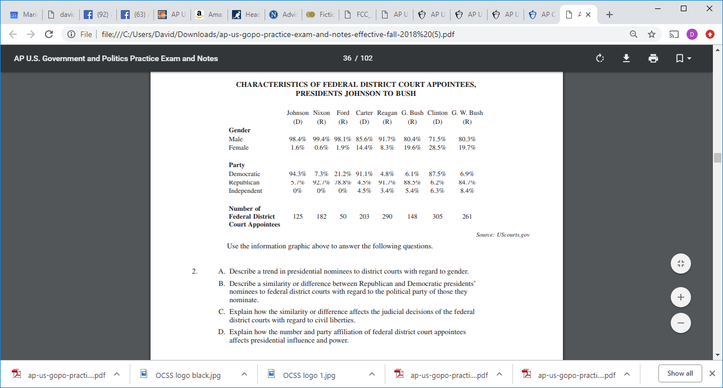

Suggestions from College Board

Students will have to:

* Identify or describe the data presented in the source
* Describe a pattern, trend or similarity/difference as prompted
* Draw a conclusion based on the analysis of the data (pattern, trend, similarity, difference)
* Explain how _____ in the information graphic demonstrates ________.

FRQ Style #3, SCOTUS Comparison

Which of the 15 Required Cases would make good comparisons to these cases? Consider drafting your own FRQ #3 that would include the facts, issue, ruling and rational and then prompt your students to compare with the best corresponding required case.

*Gibbons v. Ogden*

*Brandenburg v. Ohio*

*Abrams v. United States*

*Planned Parenthood v. Casey*

*McCutcheon v. F.E.C.*

*Heller v. District of Columbia*

*Wesberry v. Sanders*

*Abbington v. Shemp*

*Cooper v. Aaron*

*New York Times v. Sullivan*

FRQ Style #4

The argumentative essay is ripe for any government class. Consider these topics, and any of the Nine Foundational Documents as you and your students practice for the exam, and consider developing your own FRQs from these topic ideas/positions:

* Death Penalty: Is it Cruel and Unusual?
* Education Should be left to the States
* The War Powers Act is unconstitutional
* Voter ID laws
* A flat or flatter tax is the solution
* Federal regulator agencies and their power/representative democracy
* Electoral College System
* Hate Speech violates First Amendment

**Set A**

**Create Your Own FRQ with selected Text Passages and Data Sets**

*Simply examine and consider the passage and the quantitative sample, remind yourself of question format (A), (B), (C) etc., and try to draft the prompt. Once you draft the question, consider polishing it to maximize possible student answers. Write the final/best-phrased questions, and a short list of possible answers on the Yellow Sheet.*

FRQ #1

The presidency has been in crisis before; but the constitutional offense that led to the impeachment of Andrew Johnson was trivial compared to the charges now accumulating around the Nixon Administration. There are, indeed, constitutional offenses here too—the abuse of impoundment and executive privilege, for example; or the secret air war against Cambodia in 1969-1970, unauthorized by and unknown to Congress; or the prosecution of the war in Vietnam after the repeal of the Tonkin Gulf Resolution; or the air war against Cambodia after the total withdrawal of American troops from Vietnam. But these, like Andrew Johnson's far less consequential defiance of the Tenure of Office Act, are questions that a President may more or less plausibly insist lie within a range of executive discretion. The Johnson case has discredited impeachment as a means of resolving arguable disagreements over the interpretation of the Constitution in advance of final judgment by the Supreme Court.

---Historian Arthur Schlesinger, *The Atlantic Monthly*, 1973

_______________________________________________________________________________

_______________________________________________________________________________

_______________________________________________________________________________

_______________________________________________________________________________

_______________________________________________________________________________

_______________________________________________________________________________

_______________________________________________________________________________

_______________________________________________________________________________

_______________________________________________________________________________

_______________________________________________________________________________

_______________________________________________________________________________

_______________________________________________________________________________

_______________________________________________________________________________

FRQ #2

**Congressional Legislation, Five Recent Congresses**

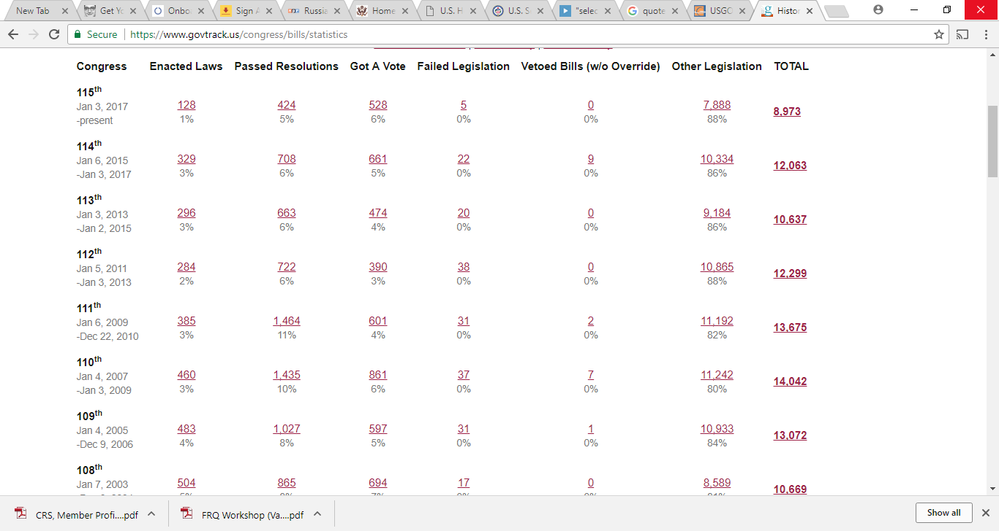

Source: Congressional Research Service

_______________________________________________________________________________

_______________________________________________________________________________

_______________________________________________________________________________

_______________________________________________________________________________

_______________________________________________________________________________

_______________________________________________________________________________

_______________________________________________________________________________

_______________________________________________________________________________

_______________________________________________________________________________

**Set B**

**Create Your Own FRQ with selected Text Passages and Data Sets**

*Simply examine and consider the passage and the quantitative sample, remind yourself of question format (A), (B), (C) etc., and try to draft the prompt. Once you draft the question, consider polishing it to maximize possible student answers. Write the final/best-phrased questions, and a short list of possible answers on the Yellow Sheet.*

FRQ #1

*To the House of Representatives:*

I am returning herewith without my approval H.R. 810, the "Stem Cell Research Enhancement Act of 2005." Like all Americans, I believe our Nation must vigorously pursue the tremendous possibilities that science offers to cure disease and improve the lives of millions. Yet, as science brings us ever closer to unlocking the secrets of human biology, it also offers temptations to manipulate human life and violate human dignity. Our conscience and history as a Nation demand that we resist this temptation. With the right scientific techniques and the right policies, we can achieve scientific progress while living up to our ethical responsibilities . . . If we are to find the right ways to advance ethical medical research, we must also be willing when necessary to reject the wrong ways. For that reason, I must veto this bill.

---President George W. Bush, Veto Message, July 19, 2006.

_______________________________________________________________________________

_______________________________________________________________________________

_______________________________________________________________________________

_______________________________________________________________________________

_______________________________________________________________________________

_______________________________________________________________________________

_______________________________________________________________________________

_______________________________________________________________________________

_______________________________________________________________________________

_______________________________________________________________________________

_______________________________________________________________________________

_______________________________________________________________________________

FRQ #2



_______________________________________________________________________________

_______________________________________________________________________________

_______________________________________________________________________________

_______________________________________________________________________________

_______________________________________________________________________________

_______________________________________________________________________________

_______________________________________________________________________________

_______________________________________________________________________________

_______________________________________________________________________________

_______________________________________________________________________________

_______________________________________________________________________________

_______________________________________________________________________________

**Set C**

**Create Your Own FRQ with selected Text Passages and Data Sets**

*Simply examine and consider the passage and the quantitative sample, remind yourself of question format (A), (B), (C) etc., and try to draft the prompt. Once you draft the question, consider polishing it to maximize possible student answers. Write the final/best-phrased questions, and a short list of possible answers on the Yellow Sheet.*

FRQ #1

I also recognized that we must have the closest bipartisan cooperation, and this included help from Senator Everett Dirksen (R-IL). On my very first TV appearance—*Meet the Press*—I praised Senator Dirksen, telling the nation that he would help, that he would support a good civil rights bill, that he would put his country above party, that he would look upon this issue as a moral issue and not a partisan issue. I believed it then, and my faith has been vindicated . . . I new that it was impossible to pass a civil rights bill, because we couldn’t possibly get cloture without Dirksen and his help. . . . You may recall that Dirksen was opposed to [parts of the bill] from the beginning . . . by working with him, talking with him day after day, appealing to his sense of patriotism and duty, which I did regularly, I was able to involve Dirksen more directly into this legislation.”

---Sen. Hubert H. Humphrey (D-MN), Memorandum on the Civil Rights Act 1964

_______________________________________________________________________________

_______________________________________________________________________________

_______________________________________________________________________________

_______________________________________________________________________________

_______________________________________________________________________________

_______________________________________________________________________________

_______________________________________________________________________________

_______________________________________________________________________________

_______________________________________________________________________________

_______________________________________________________________________________

FRQ #2

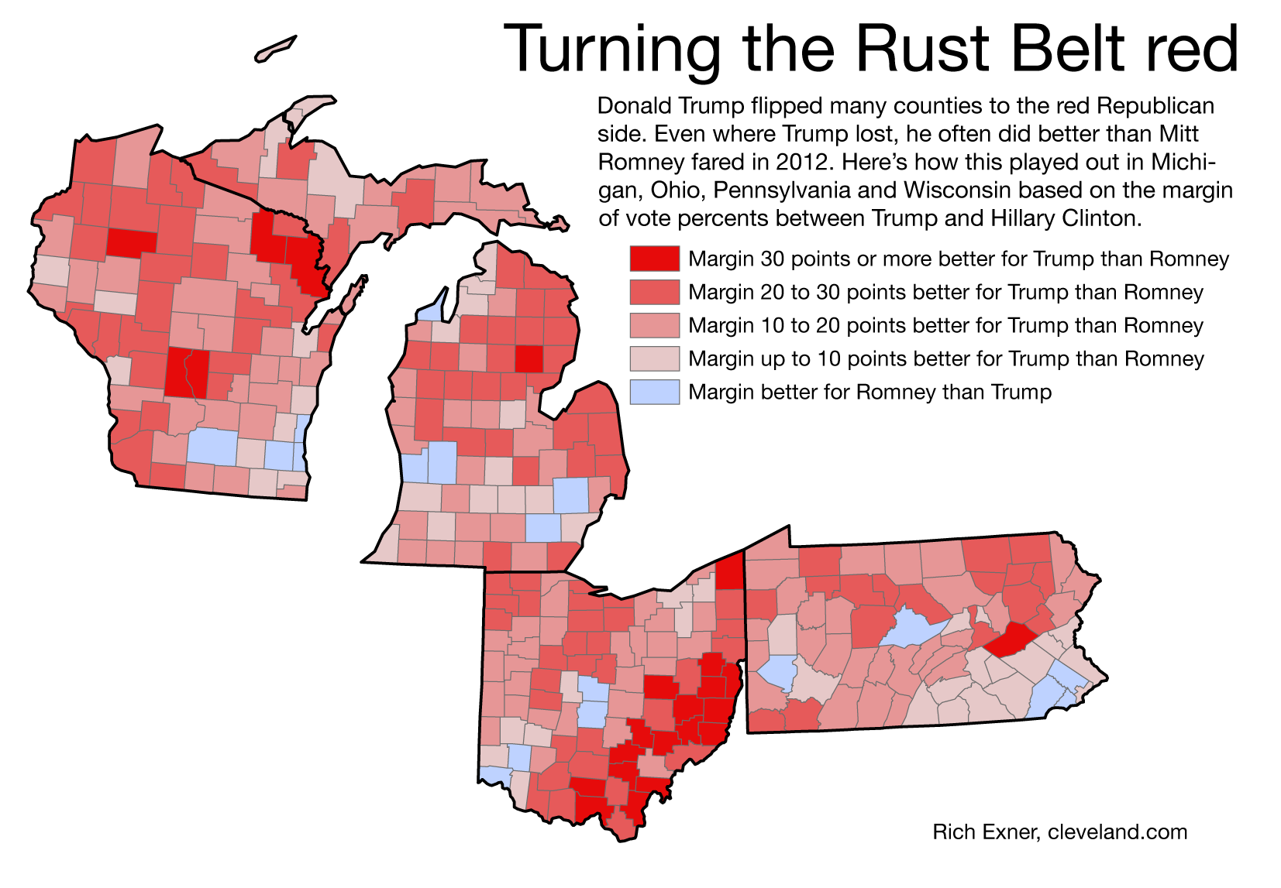

_______________________________________________________________________________

_______________________________________________________________________________

_______________________________________________________________________________

_______________________________________________________________________________

_______________________________________________________________________________

_______________________________________________________________________________

_______________________________________________________________________________

_______________________________________________________________________________

_______________________________________________________________________________

**Set D**

**Create Your Own FRQ with selected Text Passages and Data Sets**

The Secretary of Defense is in essence the deputy Commander in Chief. Just like the President, the Secretary of Defense must be prepared to carry out his military command responsibilities for 24 hours a day . . . I believe personally that [Secretary of Defense nominee] Senator [John] Tower has had a serious drinking problem . . . Standards must be set from the top down. If we want the sergeant at his post on the demilitarized zone in Korea, or the lieutenant standing alert with her SAC refueling tanker in the Midwest, to meet the high standards asked of those who wear our nation's uniform, we must make that clear here in the United States Senate.

---Senator Sam Nunn (D-GA), Senate Floor, March 2, 1989

_______________________________________________________________________________

_______________________________________________________________________________

_______________________________________________________________________________

_______________________________________________________________________________

_______________________________________________________________________________

_______________________________________________________________________________

_______________________________________________________________________________

_______________________________________________________________________________

_______________________________________________________________________________

_______________________________________________________________________________

_______________________________________________________________________________

_______________________________________________________________________________

FRQ #2

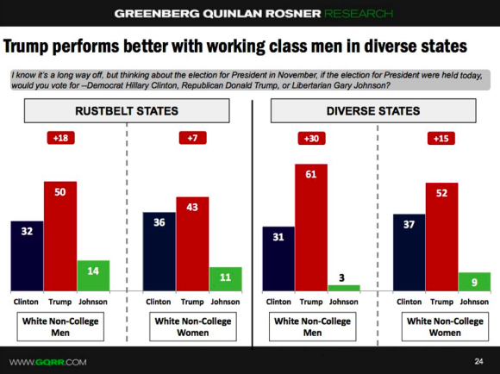

Source: Greenberg Polling, September 2016

_______________________________________________________________________________

_______________________________________________________________________________

_______________________________________________________________________________

_______________________________________________________________________________

_______________________________________________________________________________

_______________________________________________________________________________

_______________________________________________________________________________

_______________________________________________________________________________

_______________________________________________________________________________

_______________________________________________________________________________

He is a divider of the Republican Party and yet an enlarger of the tent. His candidacy is contributing to record turnouts in primary after primary, and surely bringing in Democrats and independents. But it should concern his supporters that his brain appears to be a grab bag of impulses, and although he has many views and opinions he doesn’t seem to know anything about public policy or the way the White House or the government actually works. He is unpredictable, which his supporters see as an advantage. But in a harrowing, hair-trigger world it matters that the leaders of other nations be able to calculate with some reasonable certainty what another leader would do under a given set of circumstances.

---Peggy Noonan, “The Republican Party is Shattering,” *Wall Street Journal*, March 5, 2016